|  |  |
| --- | --- |
| **DATE** |  |
| **SUBMITTED BY** | **VISHNUPRIYAN S** |
| **TITLE / ROLE** | **Online Voting System** |

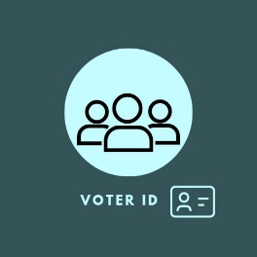 **EXERCISE NUMBER 7.1 REGISTER NUMBER:RA2111026050026**

|  |
| --- |
|  |

**7.1 STATE CHART DIAGRAM FOR ONLINE VOTING SYSTEM**

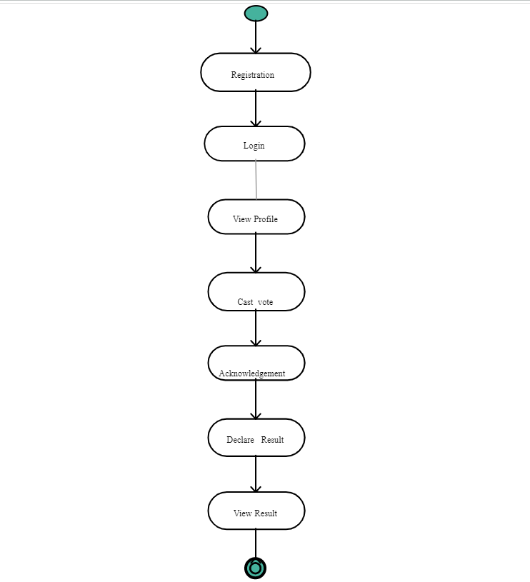

**SEQUENCE DIAGRAM:**

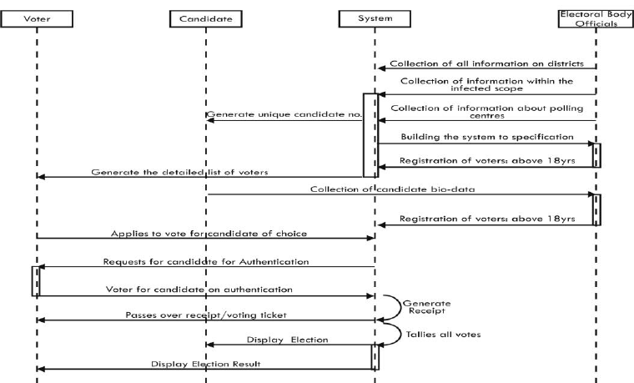

**DEPLOYEMENT DIAGRAM**

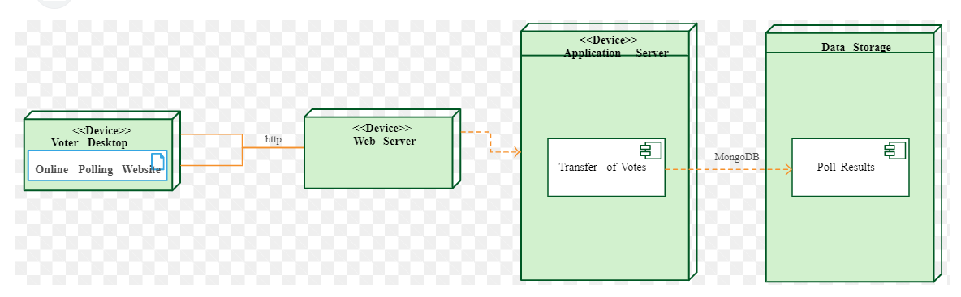

**Hardware components:**

Client devices (e.g., personal computers, mobile devices, tablets) that allow voters to access the voting system.

Load balancer for distributing incoming requests to different servers.

Application server, which hosts the voting system and processes user requests.

Database server, which stores voting data and other relevant information.

Backup server, which is responsible for backing up data and ensuring system availability in case of a failure.

**Software components:**

Front-end user interface, which is responsible for displaying the voting options and accepting votes from users.

Back-end server application, which is responsible for processing votes, storing voting data, and generating reports.

Authentication and security modules, which verify the identity of users and protect against fraudulent activities.

Database management system (DBMS), which manages the storage of data and ensures its integrity and security.

Application programming interfaces (APIs) that allow communication between different components of the system.

**Communication protocols:**

Hypertext Transfer Protocol (HTTP), which is used for communication between the client devices and the server.

Secure Sockets Layer (SSL) or Transport Layer Security (TLS), which provides a secure communication channel between the client and server by encrypting the data.

Simple Mail Transfer Protocol (SMTP), which is used to send emails for voter verification and other notifications.

Overall, the hardware and software components work together to provide a secure and reliable online voting system that allows voters to cast their votes electronically over the internet while ensuring the integrity and confidentiality of the voting process.

**7.2.USER INTERFACE DESIGN:**

**Keep it simple:** The interface should be intuitive and easy to navigate for all users, including those who may not be tech-savvy. Avoid cluttering the screen with too much information or too many options.

**Ensure accessibility:** Make sure that the interface is accessible to all users, including those with disabilities. Provide options for users to adjust font size, colour contrast, and other accessibility settings.

**Provide clear instructions:** Provide clear and concise instructions on how to use the interface, including how to cast a vote, how to verify the vote, and how to navigate through the interface.

**Use visual aids:** Use graphics, images, and other visual aids to help users understand the voting process and to make the interface more engaging.

**Ensure security:** Make sure that the interface is designed with security in mind. Use encryption and other security measures to protect against unauthorized access and tampering.

**Test with users:** Before launching the interface, conduct user testing to ensure that it is user-friendly and effective. Incorporate feedback from users to improve the design and functionality of the interface.

**Design for multiple devices:** Make sure that the interface is designed to work on a variety of devices, including desktop computers, laptops, tablets, and mobile phones. Ensure that the interface is responsive and adjusts to different screen sizes and orientations.